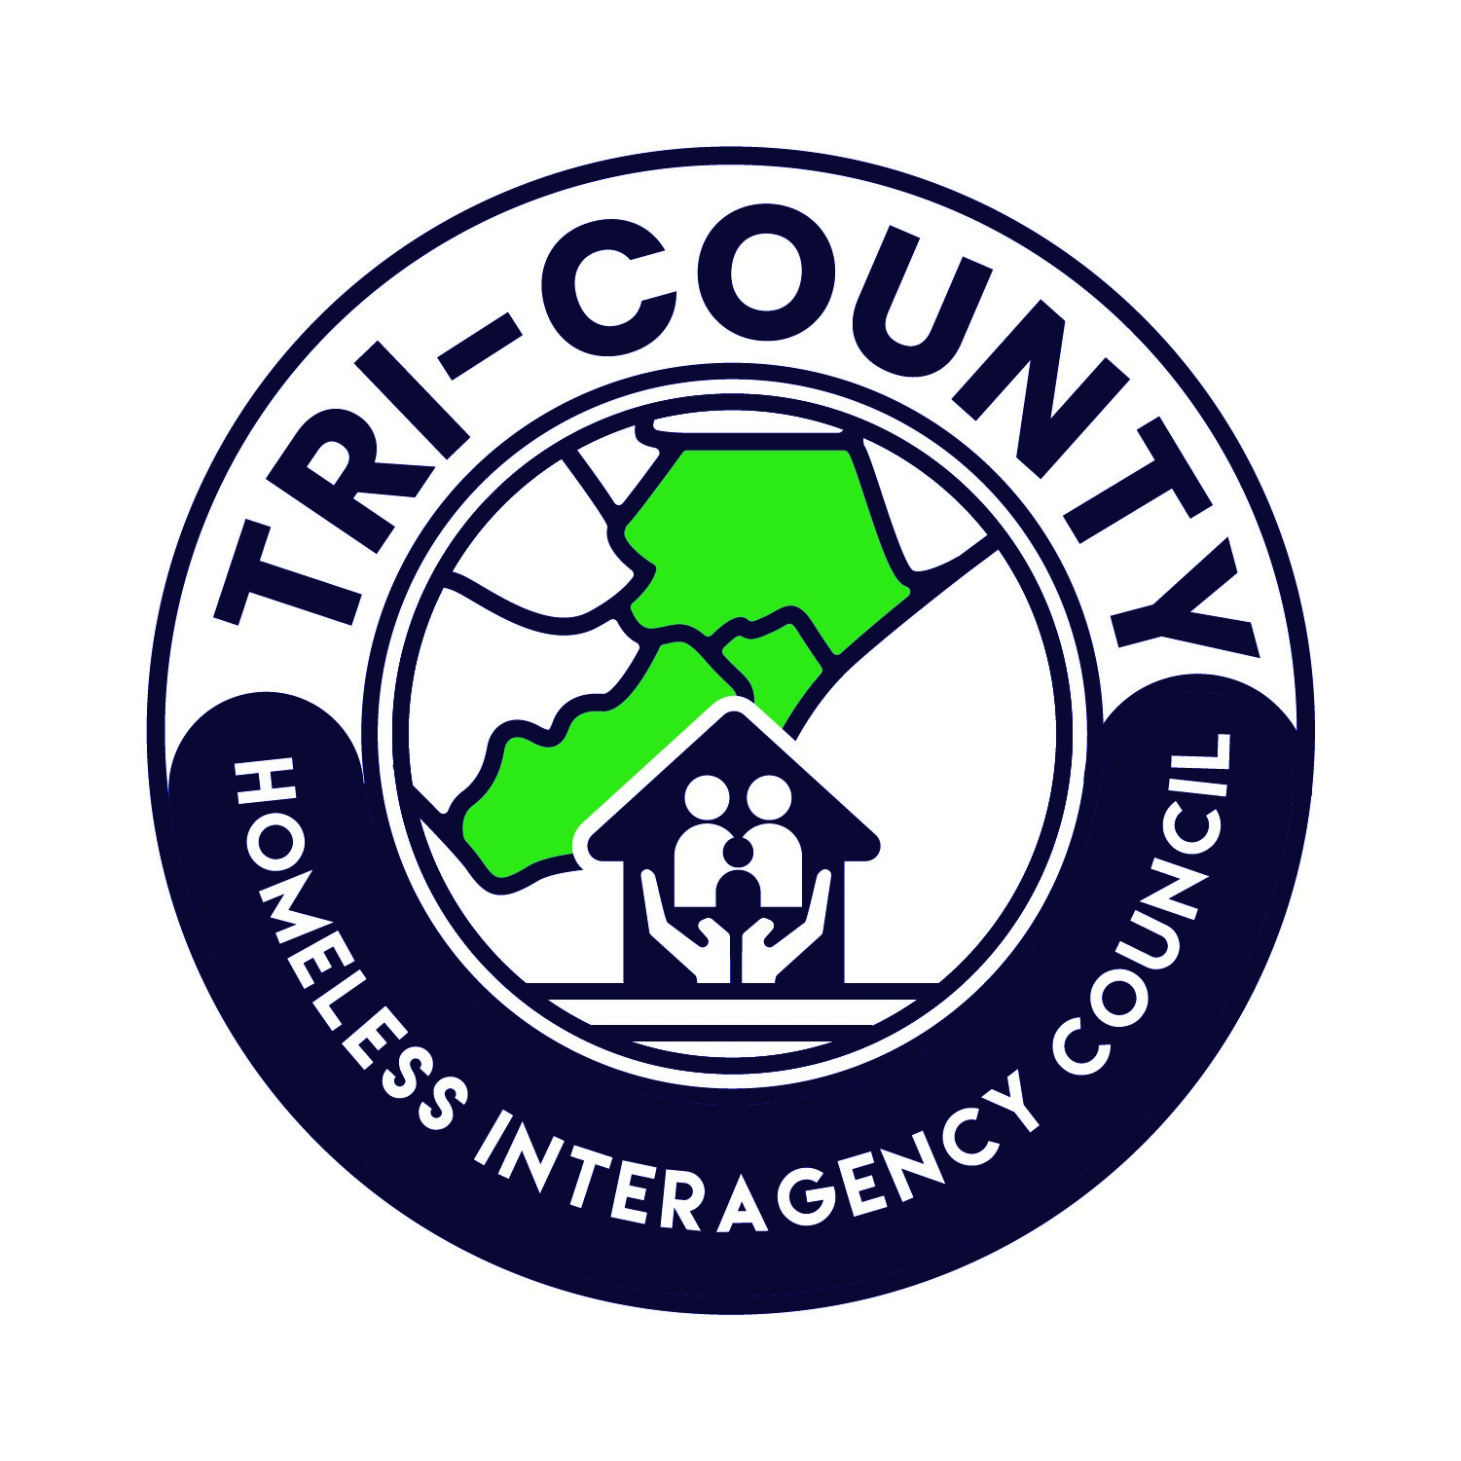 | Tri-County Homeless Interagency Council  NC-506 Continuum of Care  CoC Rating, Ranking, and Reallocation Policy

It is the goal of the Tri-County Homeless Interagency Council (Tri-HIC) to implement a Rating, Ranking and Reallocation Policy that responds to the needs of those in the community experiencing homelessness. The policy relies on objective performance measures to evaluate success and supports organizations and projects with experience in effective service delivery and stewardship of funds, regardless of the funding source (HUD, ESG, etc.). The Tri-HIC values the efforts of organizations to change, grow, and incorporate new models of best practice as the needs of the homeless service system change. The Tri-HIC requires Housing First programs and encourages creative and innovative project proposals as well as project applications from new applicants and organizations. The Tri-HIC is adopting the following policies to create a Continuum of Care (CoC) rating, ranking and reallocation process that is reflective of those goals.

CoC Ranking Committee Responsibilities
The CoC Ranking Committee is responsible for coordinating the rating, ranking and reallocation process with the Collaborative Applicant on all competition applications. The Collaborative Applicant in conjunction with the CoC Ranking Committee will create a schedule which will include timelines for establishing meetings, reviewing the collaborative application and disseminating the appeal process.

Community Priorities
Prior to each competition, the CoC Board will identify priority populations and/or project types utilizing the annual Comprehensive Data Analysis report or other comparable data i.e., the Community Health Assessments for the Counties in our service area, the Point- In-Time data etc.

Orientation Policy
Participation in CoC applicant orientation is required for all applicants prior to application submission. Orientation will provide information regarding the application requirements and process and will give applicants an opportunity to ask questions. Orientation dates and times will be announced at least two weeks prior. The CoC staff must be able to verify participation.

Application Policy and Process

Application Requirements: Applications must be submitted by the deadline established by the CoC Ranking Committee and published on the CoC website at the beginning of each Application cycle. Applications must be complete at submission and include all supporting documentation in the order established by the committee at the beginning of the Application cycle. Each application element must be clearly identified. The CoC staff will acknowledge receipt of applications.

Complete Applications: Project application responses must be specific and unique to the project. The Ranking Committee will determine which applications are complete and eligible, and only those will be scored. Applications are ranked based on the score in accordance with the ranking policy adopted by the CoC Board. (see below)

Incomplete Applications: Applicants are responsible for following instructions and guidelines for completing applications. An application that has unanswered questions or is missing required documentation will be considered incomplete. Incomplete applications are ineligible for scoring. The applicant will be notified via email to the address provided on the application, and appeal criteria will be included in the notification.

Late Applications: The CoC Staff is not permitted to accept late applications. There is no appeal process for late applications.

Ineligible/Invalid Applications: Applications containing conflicting, inaccurate and/or potentially fraudulent information will be deemed ineligible/invalid. The applicant will be notified via email to the address provided on the application, and appeal criteria will be included in the notification.

In the event the number of submitted applications does not cover the ARD, the CoC will act and apply for the remaining funds based on identified community needs and funding availability, with the goal of sub granting the funds out using an RFP process. This would be accomplished using a separate application process, the details of which will be published, after consultation with the Tri-Hic Board, on the CoC website.

Rating Policy
Projects will be rated and scored on objective factors based upon local, state and federal standards. The Ranking Committee uses CoC-approved, separate scorecards for new projects, renewal projects and projects with less than 1 year of data within each project category.

New projects will be scored using a new project scorecard.

Projects with at least one year of full operation will be scored on a renewal scorecard based on project performance, data quality and overall financial stability.

Projects with less than 1 year of data will utilize a separate renewal scorecard with a limited set of questions that allow for measurable elements.

Project applicants must be prepared to utilize HMIS or a DV comparable database if they are exclusively serving victims of DV/sex trafficking.

The score used for ranking will be a percentage, calculated by dividing the total points earned by the maximum points available.

Applicants are responsible for submitting the most recent monitoring report they received from any federal, state or local entity providing funding and/or oversight of the applicant, including all correspondence and corrective action plans.

Ranking Policy
The Tri-HIC will rank all projects according to project application score from highest to lowest based on their respective scorecard only. Whether they are a renewal or a new project will not be a factor. The tie breaker for project applications will be the cost per participant; total funding request/households served. The recommended ranking of projects will be presented to the CoC Board for their approval.

Appeals Policy and Processes
Applicants will receive communication on their project score via email using the contact information they have provided on their application. Applicants will have 48 business hours to submit a written appeal to the CoC Administrative Office. No new information can be submitted as part of the appeals process. The CoC Ranking Committee will review all appeals and respond in writing via e-mail within 7 business days of receiving the appeal. Should an applicant not be satisfied with the outcome of the appeal, they may submit a 2nd written appeal to the CoC Administrative Office, to be presented to the CoC Board, within 48 business hours of receiving their appeal response. The CoC Board will provide a final response via email within 7 business days of receiving a 2nd appeal. The CoC Board may require a meeting with the appellant and will provide 48 hours notice of the date, time, and location of that meeting. Applicants who fail to appear at a 2nd appeal meeting are forfeiting their appeal rights. Response from the CoC Board to an appeal will constitute a final determination.

Reallocation Policy and Process
The Tri-HIC is supportive of voluntary reallocation of grant funds by grantees who wish to change project type to meet community needs. Amounts that are voluntarily reallocated prior to the local application process will be added to the total available funding for other project applications. Reallocation as a result of the scoring process will be based on projects’ position in the project rankings and their alignment with community needs, as identified by the CoC Board.

It is the Tri-HIC policy that consistently underperforming projects should not be funded. The following criteria defines an underperforming project:

- A renewal project does not meet the minimum threshold for positive performance if:
  - They fall in Tier 2 in the preliminary ranking; or
  - They have financial audit or monitoring findings that they have not taken adequate steps to resolve; or
  - They are not Housing First.
- If the Ranking Committee determines that a project falls below this threshold, it will provide notes to the project specifying the reasons.
- Factors outside of an organization's control may produce project performance outcomes for one year that are not indicative of the project’s history of or capacity for positive performance overall.
- Before considering reallocation, the Ranking Committee must review three past years of performance outcomes for each project, including score card data and position on the ranked list in the three most recently completed competitions.

- The Ranking Committee will consider the following when deciding to reallocate all or part of a renewal project:
  - Project Performance - three years of historical data shows a trend of under-performance, a decline or improvement in performance, or any other discernible trend;
  - Community Need - other project applications have been submitted that have the potential to improve system performance, to which the reallocated funding could be allocated.
- Based on this review and analysis, the Ranking Committee may recommend involuntary reallocation of all or part of the renewal project’s grant.
- Funds reallocated during the application process will be added to the total available funding for other projects applications.

GLOSSARY OF TERMS

Application Cycle- The first date the funds are made available from a local, state or federal entity for which an organization can apply. The application cycle ends with the submission deadline (date and time) established by the granting entity.

ARD - Annual Renewal Demand - The ARD is the sum of all the existing projects available for renewal in an application cycle. Additional funds may be added to the ARD after an evaluation by HUD (pro rata need), plus bonus funds and CoC planning grant funds.

Collaborative Applicant – NC 506 Homeless Continuum of Care – The entity designated by the Continuum of Care to coordinate the annual application for HUD Continuum of Care program funding. The Tri-HIC collaborative applicant is the Cape Fear Council of Governments.

Community Health Assessment – A systematic process to identify and analyze community health needs conducted by each county’s health department in partnership with the local hospital. The process provides a way for the community to prioritize health needs and ways to address those needs. See the following for an example: https://health.nhcgov.com/wp-content/uploads/2020/10/FINAL-NHC-2019-CHA.pdf

Continuum of Care (CoC) Board - Tri-HIC will elect a CoC Board to serve as its governing body, its primary duty is to ensure the orderly operations of the CoC. The CoC Board shall have the power to act on behalf of and in the best interest of the Tri-HIC. The Board consists of no less than 15 and no more than 21 members, including 5 permanently assigned seats, with the remaining seats filled through an election process.

DV - Domestic Violence

eLoccs - The Electronic Line of Credit Control System - the financial management system for HUD grants.

Grant Cycle - A Grant Cycle begins upon the execution of a Grant Agreement with the funding agency and ends with the expiration of the grant, including any extensions.

HMIS - Homeless Management Information System - The database used to track individuals experiencing homelessness. It tracks data related to programs that house said individuals and can be accessed by service providers trained on the system.

Homeless Continuum of Care (CoC) - The HUD designated oversight body for the homeless service system of a particular region or community. The Tri County Homeless Interagency Council (Tri-HIC) is the HUD designated Continuum of Care (CoC) for Brunswick, Pender and New Hanover Counties.

HUD- The United States Department of Housing and Urban Development

New Project - A project not currently funded, even if it has been funded in the past.

Point-in-Time Count – An annual count of sheltered and unsheltered people in the CoC’s designated catchment area. HUD requires an annual count to be conducted during the last 10 days of January each year. See: Data - Cape Fear Council of Governments (capefearcog.org)

RFP - Request for Proposal

Renewal Project - A project that is currently funded and has applied to renew its grant funding.

