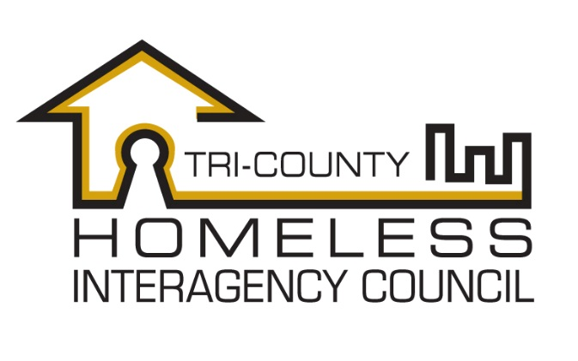
Request for Proposals
For the Facilitation of a Governance and Structure Analysis and Development Process.

Through this Request for Proposals the Tri-County Homeless Interagency Council, the homeless continuum of care for Brunswick, Pender, and New Hanover County is seeking proposals from qualified applicants to conduct an analysis of the organizational structure and governance to support organizational development toward meeting its mission and vision.

Date of Issue: December 18, 2017

Submissions Due: January 5, 2018

Project Contact:
Joanne Cain
The Arc of North Carolina
5041 New Centre Drive, Suite 100
Wilmington, NC 28403
Tel: 910-523-0415
E-mail: jcain@arcnc.org

- Purpose

The Tri-HIC homeless continuum of care for the City of Wilmington, Brunswick, New Hanover and Pender Counties seeks to engage a consultant (herein referred to as the “candidate”) in the analysis of the organization’s current structure, including governance model, membership, and committees/workgroups to assist the organization in developing the most effective engagement of it’s members and use of their efforts to meet our mission and goals. The Continuum of Care (CoC) expects the candidate to use best practices in organizational development and planning, and to engage all relevant partners, stakeholders and community members that are impacted by the work of the continuum of care. The CoC will use the results of this process to make the necessary changes to best position the organization in its work to prevent and end homelessness in the region.

- Background

The Continuum of Care is an alliance of over 50 service providers, local government agencies, and other public interests whose common goal is the prevention and reduction of homelessness in the Cape Fear Region. The CoC is made up of general members, who have voting authority on matters related to the CoC structure and funding decisions, and an Advisory Board, which supports the cross-communication and planning with elected leadership and other service systems and community organizations. Under the HEARTH Act, the CoC became the driving force in developing a systematic response to homelessness that makes data-driven funding decisions. Prior to the HEARTH Act, the administrative arm of the CoC was our 10 Year Plan to End Homelessness, hosted at United Way. With the sun setting of the 10 Year Plan, our CoC has placed an Administrator at the Cape Fear Council of Governments to oversee CoC activities, grant application processes, reporting and compliance.

On an annual basis, our CoC brings in over $817,000 in federal and state funds to provide emergency services and housing to individuals and families who are homeless. This is used to serve the approximately 1200-1300 people per year that are homeless and seeking services through one or more shelter, transitional housing, and permanent housing programs. During the January 2017 Point In Time Count, a one day count of those who are literally homeless, there were 322 people identified as homeless. Over the past 6 years, our community has seen a continued reduction in the number of sheltered and unsheltered homeless. A lack of affordable housing threatens to curb the progress that the CoC has made in reducing the numbers of homeless. Changing expectations of funders and more competitive funding processes has presented a burden for the general operations of key service providers. Increasingly complex reporting and compliance requirements have shifted the work of the CoC staff and committees.

- Project Overview

The CoC seeks a new planning process that will help membership and leadership understand our strengths and weaknesses with regard to our ability to meet our mission, as well as how our members understand their role and contribution with regard to the mission and organizational impact. The CoC hopes to improve use of members time and talents to accomplish the mission, including conducting all the required work of the organization, as well as understand where recruitment would assist in spreading the workload and build organizational strength where it is needed.

The candidate is expected to introduce the process to both the CoC General Membership and Advisory Board, outlining the goals of the process, participation expectations in order to make the process effective, a timeline for completion, and what the anticipated outcomes will be.

The CoC anticipates that the candidate will produce a summary of current structure, stakeholder feedback, and recommendations to make the work of the organization more efficient and effective in meeting its mission and goals.

The candidate is expected to complete the project by June 30, 2018. The budget for this project is expected to range from $9,000 - $11,000, with costs not to exceed $11,700.

- Timeline

The Continuum of Care is expecting the RFP, contracting and project to follow the timeline below:

Request for Proposals Issued: December 13, 2017
Proposals Due: January 5, 2018
Announcement of Candidate: January 19, 2018
Execution of Contract: (on or before) January 31, 2018
Completion of Contract June 30, 2018

The deadline to submit proposals is January 5, 2018 at 5pm EST. Proposals will be considered received by e-mail timestamp or by postmark on the date indicated. Proposals should be submitted to the e-mail or mailing address listed at the top of this RFP. No proposals will be accepted by fax. All proposals will be considered confidential and detail of proposals, outside of proposing organization name, will not be shared outside of the project selection committee and the funding agency upon request.

Questions regarding this RFP should be submitted via e-mail to the e-mail address listed on the top of this RFP. Responses to all questions received will be made available to any candidate who requests them in writing.

- Evaluation of Proposals

Proposals will be evaluated based primarily on the candidate’s ability to provide the services requested in the time frame desired, and will also take into consideration cost, staffing plan, experience, and professional references.

- Response to Proposals

All candidates submitting a proposal will receive a response as to whether their proposal has been accepted or not, or if more detail is needed from a candidate in order to approve a proposal, a provisional acceptance, by January 19, 2018.

